VAISHNAVI E 231901059
EXERCISE 8
Perform rootkit detection and removal using rkhunter tool

AIM:
Perform real-time file system analysis on a Linux system to identify an attacker's artifacts.
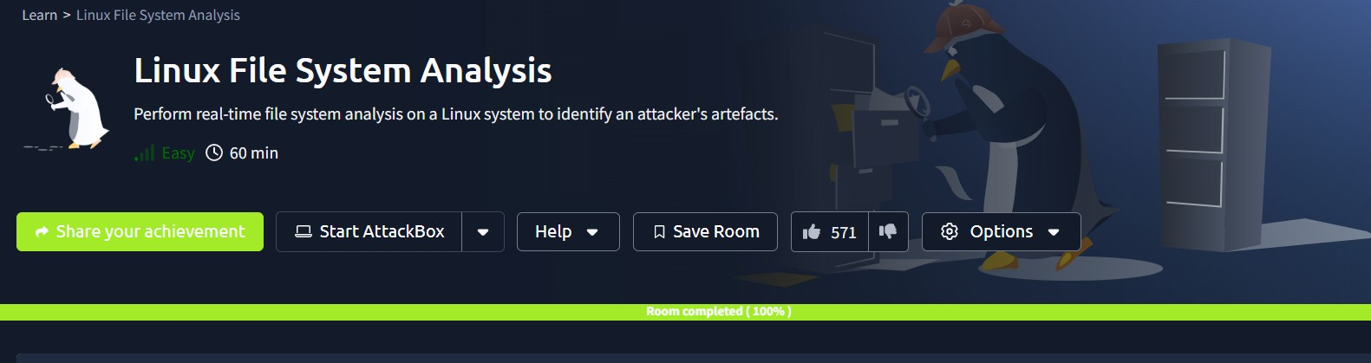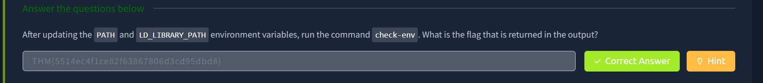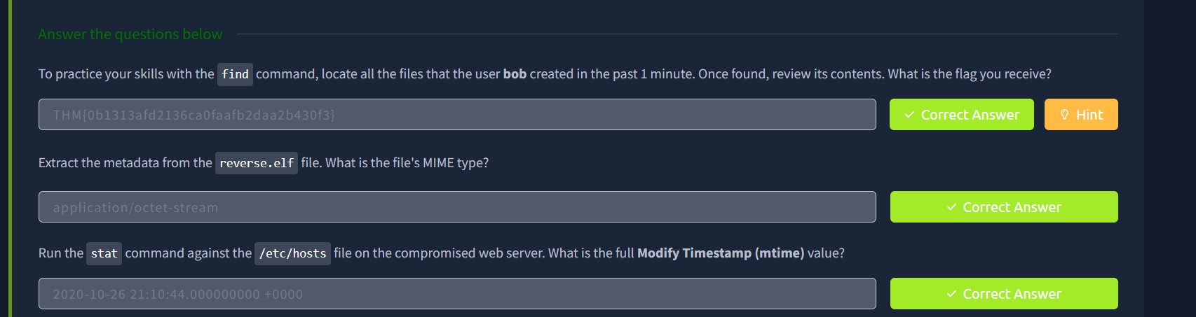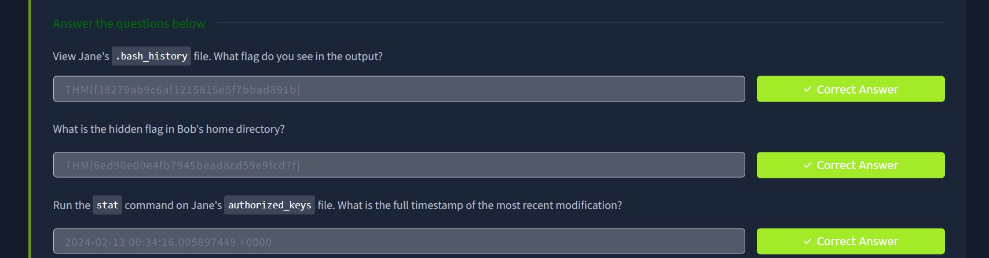
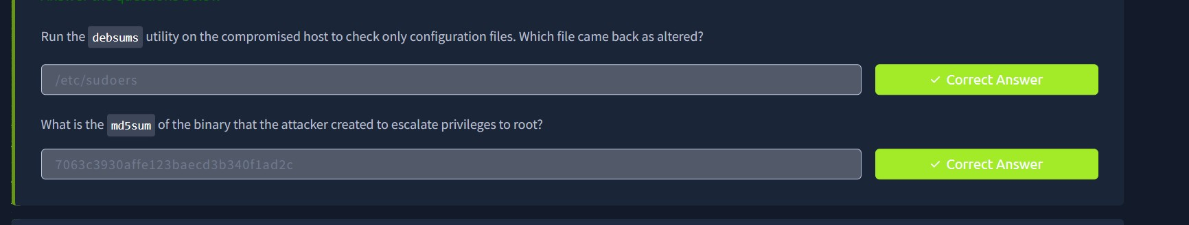

RESULT:
Identified malicious files, unauthorized modifications, and suspicious activities in the file system logs.

